SEC Form 3
FORM 3 | UNITED STATES SECURITIES AND EXCHANGE COMMISSION
 | Washington, D.C. 20549
 | Washington, D.C. 20549 |  | OMB APPROVAL
 | INITIAL STATEMENT OF BENEFICIAL OWNERSHIP OF SECURITIES
 | INITIAL STATEMENT OF BENEFICIAL OWNERSHIP OF SECURITIES |  | OMB Number: | 3235-0104
 |  |  | Estimated average burden
 | Filed pursuant to Section 16(a) of the Securities Exchange Act of 1934 |  | hours per response: | 0.5
or Section 30(h) of the Investment Company Act of 1940
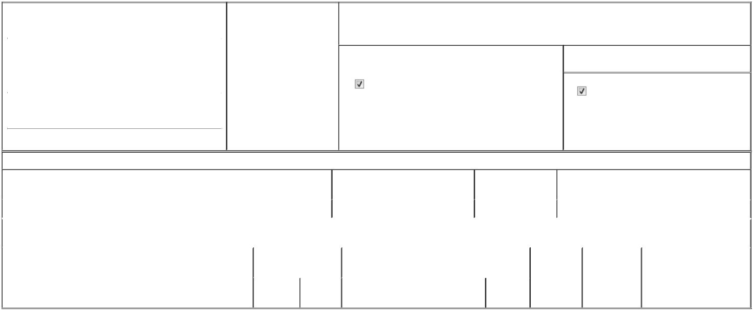

1. Name and Address of Reporting Person* |  |  |  | 2. Date of Event Requiring
 |  | Zmigrosky Matt |  | Statement (Month/Day/Year)
 |  | Zmigrosky Matt |  | 08/19/2025

3. Issuer Name and Ticker or Trading Symbol

Viper Energy, Inc. [ VNOM ]

 | (Last) | (First) | (Middle)
 | 500 WEST TEXAS AVENUE
 | SUITE 100
(Street)
 | MIDLAND | TX | 79701

- Relationship of Reporting Person(s) to Issuer (Check all applicable)
Director | 10% Owner
Officer (give title | Other (specify below)
below) | Other (specify below)

Exec. VP, Gen Counsel and Sec

- If Amendment, Date of Original Filed (Month/Day/Year)

- Individual or Joint/Group Filing (Check Applicable Line)

Form filed by One Reporting Person

Form filed by More than One Reporting Person

(City) (State) (Zip)

Table I - Non-Derivative Securities Beneficially Owned

1. Title of Security (Instr. 4) | 2. Amount of Securities Beneficially | 3. Ownership Form: | 4. Nature of Indirect Beneficial Ownership (Instr. 5)
 | Owned (Instr. 4) | Direct (D) or Indirect
 |  | (I) (Instr. 5)

 | Class A Common Stock |  |  |  | 4,253 | D
 |  |  | Table II - Derivative Securities Beneficially Owned
 |  | (e.g., puts, calls, warrants, options, convertible securities)
 | 1. Title of Derivative Security (Instr. 4) |  | 2. Date Exercisable and |  | 3. Title and Amount of Securities Underlying |  | 4. | 5. Ownership | 6. Nature of Indirect Beneficial
 |  |  | Expiration Date |  | Derivative Security (Instr. 4) |  | Conversion | Form: Direct | Ownership (Instr. 5)
 |  |  | (Month/Day/Year) |  |  |  | or Exercise | (D) or Indirect
 |  |  |  |  |  |  | Price of | (I) (Instr. 5)
 |  |  |  |  |  | Amount or | Price of | (I) (Instr. 5)
 |  |  |  |  |  | Amount or | Derivative
 |  |  | Date | Expiration | Title | Number of | Security
 |  |  | Exercisable | Date | Title | Shares

Explanation of Responses:

Remarks:

In accordance with the completion of the transactions contemplated by the Agreement and Plan of Merger (the "Merger Agreement"), dated as of June 2, 2025, by and among VNOM Sub, Inc. (f/k/a Viper Energy, Inc.) ("Former Viper"), Viper Energy, Inc. (f/k/a New Cobra Pubco, Inc.) ("New Viper") and the other parties thereto, on August 19, 2025, shares of Class A common stock, par value $0.000001 per share, of Former Viper (and awards of restricted stock units in respect of such Class A common stock), were converted into an equivalent number of shares of Class A common stock, par value $0.000001 per share, of New Viper (and awards of restricted stock units in respect of such Class A common stock), in each case, in accordance with the terms of the Merger Agreement. Exhibit List: Exhibit 24 - Limited Power of Attorney

 | /s/ Matt Zmigrosky |  |  | 08/19/2025
 | ** Signature of Reporting Person |  | Date
Reminder: Report on a separate line for each class of securities beneficially owned directly or indirectly.
* If the form is filed by more than one reporting person, see Instruction 5 (b)(v).
** Intentional misstatements or omissions of facts constitute Federal Criminal Violations See 18 U.S.C. 1001 and 15 U.S.C. 78ff(a).
Note: File three copies of this Form, one of which must be manually signed. If space is insufficient, see Instruction 6 for procedure.
Persons who respond to the collection of information contained in this form are not required to respond unless the form displays a currently valid OMB Number.



