Filed by Viper Energy, Inc.
Filing pursuant to Rule 425 under the
Securities Act of 1933, as amended
Deemed filed pursuant to Rule 14a-12 under the
Securities Exchange Act of 1934, as amended
Subject Company: Sitio Royalties Corp.
Commission File Number: 001-41585
Explanatory Note: The following is a transcript from an investor call held of June 3, 2025, in connection with Viper Energy, Inc.s proposed acquisition of Sitio Royalties Corp. Also included are the press release and the investor presentation for the transaction.
Call Participants
EXECUTIVES
Austen Gilfillian
President of Viper Energy Partners GP LLC
Chip Seale
Matthew Kaes Vant Hof
CEO & Director of Viper Energy Partners GP LLC
ANALYSTS
Leo Paul Mariani
ROTH Capital Partners, LLC, Research Division
Neil Singhvi Mehta
Goldman Sachs Group, Inc., Research Division
Paul Michael Diamond
Citigroup Inc., Research Division
Timothy A. Rezvan
KeyBanc Capital Markets Inc., Research Division

1

Presentation
Operator
Good day, and welcome to the Viper and Sitio merger conference call. [Operator Instructions]
As a reminder, this call may be recorded. I would now like to turn the call over to Chip Seale, Investor Relations Director. Please go ahead.
Chip Seale
Thank you, Michelle. Good morning, and welcome to our call announcing the merger between Viper Energy Inc. and Sitio Royalties Corporation. During our call today, we will reference an investor presentation, which can be found on Vipers website.
Representing Viper today are Kaes Vant Hof, CEO; and Austen Gilfillian, President.
During this conference call, the participants may make certain forward-looking statements relating to the companys financial conditions, results from operations, plans, objectives, future performance and businesses. We caution you that actual results could differ materially from those that are indicated in these forward-looking statements due to a variety of factors. Information concerning such factors can be found in the companys filings with the SEC.
I will now turn the call over to Kaes.
Matthew Kaes Vant Hof
CEO & Director of Viper Energy Partners GP LLC
Thank you, Chip. Welcome, everyone, and thank you for listening to todays call. Today is an exciting day for Viper, Sitio, and the minerals business in general. Were excited to announce that today, Viper and Sitio are merging. Viper will acquire Sitio and all equity transaction valued at approximately $4.1 billion, including Sitios net debt of approximately $1.1 billion as of end of first quarter of 2025. The consideration will consist of 0.4855 shares, a pro forma Viper for each share of Sitio Class A common stock, representing an implied value to each Sitio stockholder of $19.41 per share based on the closing price of Viper common stock yesterday, June 2, 2025.
This transaction was unanimously approved by the Board of Directors of each company and has been approved by written consent of Diamondback as Vipers largest stockholder. Second, stockholders holding an approximately 48% of Sitios outstanding voting power have agreed to vote in favor of the transaction. This transaction is expected to close in the third quarter of 2025, and is subject to customary regulatory approvals.
Were excited about this deal for multiple reasons. First, most importantly, size and scale. This transaction had substantial scale and inventory depth that will support pro forma Vipers durable production profile and free cash flow growth over the next decade. Sitio owns approximately 25,300 net royalty acres in the Permian Basin. They also own an additional 9,000 net royalty acres, primarily in the DJ, Eagle Ford and Williston Basins. While we are excited about the acreage outside the Permian, we intend to continue to be a Permian-focused company and see the other basins as upside to our base case projections.
Pro forma Viper will own approximately, 85,700 net royalty acres in the Permian Basin and produce approximately 66,000 barrels of oil per day and over 125,000 BOEs a day by the fourth quarter of this year, which is expected to be the first full pro forma quarter post close.
Second, this deal offers meaningful financial accretion and higher cash returns at a lower breakeven. We expect this transaction to be approximately 8% to 10% accretive to cash available for distribution per share immediately upon closing and expect that accretion to grow thereafter as synergies are realized. Viper is extremely focused on per share metrics, and this deal increases all relative per share metrics immediately. The Board also approved a 10% increase to Vipers base dividend in conjunction with this transaction effective immediately. Even with this increase, this deal reduces pro forma Vipers base dividend breakeven by approximately $2 per barrel to sub-$20 WTI. Vipers increased base dividend represents approximately 45% of cash available for distribution at $50 WTI.
Next, this transaction offers significant tangible synergies. We estimate the total synergies to be more than $50 million annually, primarily attributable to G&A and cost of capital savings. Pro forma Viper is expected to maintain its investment-grade status and pro forma leverage is expected to be approximately 1.2x at closing at current strip pricing. We expect to execute a significant liability management exercise as part of this trade to reprice all of Vipers pro forma full debt stack.
We also announced today a near-term net debt target of $1.5 billion, which we expect to achieve through free cash flow generation and potentially noncore asset sales.
Finally, I think its important to highlight that the Diamondback relationship remains strong and a distinct competitive advantage for Viper. Diamondback is expected to own approximately 42% of pro forma Vipers outstanding common stock after closing and will continue to drive meaningful long-term oil production growth from the companys acreage.
From a Diamondback perspective, this deal meaningfully increases the distributions received each quarter on approximately 155 million shares that they own at Viper.
In conclusion, we continue to believe that Viper presents a differentiated investment opportunity and todays merger only enhances our position as we look to compete with mid- and large-cap E&Ps for investor dollars attention and access to capital.
Operator, please open the line for questions.

2

Question and Answer
Operator
[Operator Instructions] And our first question comes from Neil Mehta with Goldman Sachs.
Neil Singhvi Mehta
Goldman Sachs Group, Inc., Research Division
Yes. Kaes and team, congratulations on the transaction. A couple of questions. First, just a better understanding of the customer base over at Sitio for those of us who know the story a little bit less. It looks like a lot of this acreage is on the Delaware side. One of the things thats really distinctive about the VNOM side is just how strong the customer base you have is. And so just talk about who youre going into business with in the Delaware and how you feel about the acreage that youre picking up here?
Matthew Kaes Vant Hof
CEO & Director of Viper Energy Partners GP LLC
Yes, Neil, I think high level, weve watched Sitio grow their business over time. And I think youd expect that we knew almost every trade that they built their business on. We did a lot of work studying the Delaware Basin and the operator group there. I think its all the big ones you would expect, a lot of Conocho, a lot of OXY, a lot of EOG, I think if theres a bigger New Mexico position that were excited about that we didnt have a significant position in prior. And Ill let Austen give a few more details.
But high level, I would say, as a mineral owner, we love the Delaware Basin. The stack pay is significant. You remove some of the higher-cost operating challenges as a mineral owner. And I think theres a lot of resource left to be developed. And some of these trades, as you can expect, and I said earlier, we know them very, very well. And we think were getting them now under the Viper hood at good value. So Austen, do you want to give a little breakdown?
Austen Gilfillian
President of Viper Energy Partners GP LLC
Yes. So I mean, I would say, first off, on their asset base, they own some pretty concentrated acreage position in the Delaware Basin. Its a little bit more diversified to a broader set of operators than we have at Viper. But if you look at the top of the list, its really still going to be the large cap operators that you want to own under asset mineral owner that its going to be an operator that capitalizes and develops the asset appropriately really by the top operators in terms of current production would be Chevron, Exxon and Occidental in orders. Such cases point, weve been really interested in watching the asset develop over the years and having this opportunity to get under the hood and really dig into it. Were really excited about really the breadth of the asset base, the existing production, and equally, its important, I think the runway that this adds, thats a little bit different than what we previously owned at Viper.
Matthew Kaes Vant Hof
CEO & Director of Viper Energy Partners GP LLC
Yes. One more thing, Neil, before you follow up. I mean I think the way we think about this is we have a very highly concentrated position under Diamondback, which is the differentiator. And then outside of that, we have a kind of more of a broad basin approach as we get more size and scale, having a bigger basin approach, I think, is appropriate for the non-Diamondback operated piece.
Neil Singhvi Mehta
Goldman Sachs Group, Inc., Research Division
Okay. Thats really helpful, Kaes. And then just talk about what this all means for a return of capital, which is a big part of the instrument. It looks like this is going to be an accretive deal and lower breakevens by $2 a barrel as well. So what does that ultimately mean for your ability to return capital in a choppier oil macro?
Matthew Kaes Vant Hof
CEO & Director of Viper Energy Partners GP LLC
Yes. Listen, I think it means we can return more sooner. Were going to keep our 75% minimum commitment to equity at Viper. We raised the base dividend. So thats a little bit of a higher percent of the total return on capital base. I think were probably headed towards a base dividend increase at some point this year anyway. So this deal only accelerates that. As you mentioned, deals accretive, distributions go up immediately. And I think this business has a lot of flow, a lot of liquidity. I think its going to get a lot more investor attention. We still have our buyback program in place in case there are any large holders that do want to hit the exits. But the primary return of capital is still going to be 75% going back to equity holders with a combination of a base plus variable dividend with kind of flexibility outside of that.
And I think the last thing Ill say there is the mineral business, being pure free cash flow, delevers very quickly. So even with our 2 businesses working towards closing over the next 3 months or so, well delever by another couple of hundred million dollars before the deal even closes. And thats just a testament to this business model.

3

Operator
Our next question comes from Paul Diamond with Citi.
Paul Michael Diamond
Citigroup Inc., Research Division
First, congratulations on the transaction. I just wanted to touch base on the non-Permian asset base? I know you talked about liking the optionality in the upside, but also talked about noncore asset sales. I just wanted to see if I can get an idea of the balance between those two.
Matthew Kaes Vant Hof
CEO & Director of Viper Energy Partners GP LLC
Yes. Paul, I mean I think its very price dependent. They have 3 large assets outside the Permian, DJ being the biggest, Eagle Ford second, Williston third. I think all 3 of those deals or all 3 of those positions are kind of, of the size that we think would be a very competitive process should we decide to sell them.
I think the other side of that coin, though, is we have a very strong balance sheet and we have time and we can be patient monetizing these assets at higher commodity prices eventually down the line, which reduces the purchase price significantly.
Last, Id say is the Eagle Ford asset, were very familiar with. We actually owned a very similar piece of that same asset a few years ago. They own a larger piece, but were comfortable with that position. Its in a really good spot in the Eagle Ford. But we also know that the market for minerals in the private world and that kind of $50 million to $200 million space is highly competitive. Weve been kind of blown out on deals in that size in the Permian. And so thats why I think theres going to be a competitive market for some of these assets at the right time.
Paul Michael Diamond
Citigroup Inc., Research Division
Understood. Makes perfect sense. And then just one other quick follow-up. The time and the net debt target, $1.5 billion. Could you give me kind of your outside view on how that looks for timing? Is that a closed  or is that a mid 26 story? Or I guess how are you thinking about getting to that number timing wise?
Matthew Kaes Vant Hof
CEO & Director of Viper Energy Partners GP LLC
Yes. I think we get there by mid 26 without selling anything, which is pretty unique. And I think weve done a lot of work with the rating agencies. Viper is now investment grade. We expected to hold its investment-grade rating. I think the rating probably should go higher over time. If you think about net debt to EBITDA at a mineral company, and thats really net debt to free cash flow versus an upstream company thats either reinvesting 50% or 75% of its cash flow and the CapEx at $60 oil. This business doesnt reinvest any. And so its a strong credit. I think the credit markets recognize that its a strong credit. And one of the big synergies here is being able to kind of reprice our entire balance sheet combined with Sitios into that investment-grade world.
Operator
Our next question comes from Leo Mariani with ROTH.
Leo Paul Mariani
ROTH Capital Partners, LLC, Research Division
Yes. I just wanted to kind of touch base on sort of growth here. Clearly, the Viper stand-alone business had some very nice built-in growth over time. Kind of eyeballing some of the Sitio kind of production numbers. Im not as familiar of that story. It looks like their oil production was a little flatter, maybe not as much growth as VNOM.
So just trying to kind of get a sense of kind of where do you see that kind of stand-alone Sitio growth, say, into 2026. Do you expect that kind of relatively flat. How should we think about that? It certainly seems like the pro forma growth might come down a little. I just want to get your thoughts on that.

4

Matthew Kaes Vant Hof
CEO & Director of Viper Energy Partners GP LLC
Yes. I think, Leo, theres less growth at the Sitio side that we see today. But again, its a massive asset base. I think were increasing our asset base by over 40%. So theres a lot of optionality for growth in the future. Obviously, I had a much better line of sight to the Viper growth, which is still planning on happening in 26 and beyond.
I think Ill kind of point your attention, rather, to the per share growth, right? At the end of the day, we want our shareholders to own more oil production, more acreage, more cash flow, and more free cash flow per share over time. And I think the accretive nature of this transaction, the multiple spread between parent or between Diamondback, Viper and Sitio, combined with the organic growth profile of Viper standalone is going to give you a pretty significant bump to per share metrics in 26.
Leo Paul Mariani
ROTH Capital Partners, LLC, Research Division
Okay. That makes a lot of sense. Just wanted to kind of follow up on some of the uses of free cash flow here. You guys kind of mentioned in your prepared comments that if there were some shareholders that wanted to exit, you guys could kind of be supportive from a buyback perspective. But it also sounded like theres going to be some prioritization of paying down debt with kind of the goal you guys laid out for kind of middle of next year, the $1.5 billion of net debt. So maybe you could expound upon that a little bit. Obviously, you guys did do some regular way buyback of the stock over the last couple of months for the first time in a while. Should we assume that perhaps the prioritization is debt paydown, but more of the free cash flow over sort of the next 12 months? How should we think about it?
Matthew Kaes Vant Hof
CEO & Director of Viper Energy Partners GP LLC
No. I mean, listen, I think its important to note that were keeping our 75% return commitment to equity and 25% to the balance sheet or to do deals. I think this combined business, again, going back to debt to EBITDA versus debt to free cash flow, its probably underlevered, but we still think its appropriate to delever.
So again, the base case is pay the base dividend, pay out the rest in terms of a variable dividend up
to 75% of free cash flow, but we do have some flexibility if theres a natural seller or if theres more weakness in the commodity, the step up on the buyback like we did about a month ago. Obviously, weve been in negotiations for a period of time. So weve had to be a little cautious on our buyback. But at some point, well have ultimate flexibility to buy back more shares if needed.
I think one other thing, Leo, on the other side, obviously, they had 3 large private equity holders in Kimmeridge, Blackstone and Oaktree, I think they saw the value in combining these businesses to get more flow, more liquidity and trade into an investment-grade stock that, as we mentioned in the call, is now a top 10 E&P in North America in terms of  or in the U.S. in terms of size and scale.
So theres a lot of levers we can pull at Viper over the coming years, and we think this is just another step towards kind of being the big mineral champion in the public markets.
Operator
[Operator Instructions] Our next question comes from Tim Rezvan with KeyBanc Capital Markets.
Timothy A. Rezvan
KeyBanc Capital Markets Inc., Research Division
Kaes, you mentioned in your prepared comments, liability management at closing. Can you explain a little more what that means? And looking at where Sitio and your debt trades, youre trading at a pretty attractive rate. So just trying to understand what you meant with that comment.
Matthew Kaes Vant Hof
CEO & Director of Viper Energy Partners GP LLC
Yes. Tim, Sitio has a senior note outstanding kind of at a little higher rate. Viper has a note outstanding that we can  that was this callable today. I think weve kind of been waiting to call that note and reprice all that with one big trade. I think second to that Sitio panel in our minds, a pretty significant amount drawn on the revolver, $500 million to $600 million, depending on the day. I think we would probably prefer that to be in more of a term like structure with no call protection that investment-grade deal offers. I dont think were looking to  I dont think were looking to touch the 30-year or longer end of the current year with 30-year rates as high as they are. But I think repricing this balance sheet in the kind of 5-year, 10-year fashion and giving us ultimate flexibility to do stuff between now and then is a good place to be and a long way from where we were at Viper just a few years ago.

5

Timothy A. Rezvan
KeyBanc Capital Markets Inc., Research Division
Okay. So I assume that potential savings is baked into that synergy target?
Matthew Kaes Vant Hof
CEO & Director of Viper Energy Partners GP LLC
Thats right. Its probably about 1/3 of that synergy target.
Timothy A. Rezvan
KeyBanc Capital Markets Inc., Research Division
Okay. Okay. Thats great. And then just thinking about the other synergies. You have  G&A has been just under $1 a BOE. I know the beauty of the minerals business is that integration is sort of just transferring buyers to your bank account. But how should we think about the size of the organization afterwards and what your cash OpEx could look like?
Matthew Kaes Vant Hof
CEO & Director of Viper Energy Partners GP LLC
Yes. I think weve grown our business significantly at Viper. We are kind of branching out away from the Diamondback umbrella, building different groups over time. Sitio has some very talented people that work there that were going to speak to today and over the coming months. I think there are certainly gaps we need to continue to fill at Viper, but overall, I think, in general, youll still see best-in-class G&A probably coming down a little bit given the amount of BOEs were adding.
So theres some  theres certainly some gaps and we need some talent, and were going to start working on that today, but G&A is coming down pro forma on a BOE basis.
Operator
There are no further questions. Id like to turn the call back over to Kaes Vant Hof, CEO, for closing remarks.
Matthew Kaes Vant Hof
CEO & Director of Viper Energy Partners GP LLC
Thanks again, everybody, for joining todays call. Again, an exciting day for Viper and for Sitio and for the minerals market. We continue to believe that size and scale will be rewarded in this business, and our little mineral company, Viper, has come a long way. So please reach out if you have any questions, and have a great day.
Operator
Thank you for your participation. You may now disconnect. Everyone, have a great day.

6

Forward-Looking Statements
This communication relates to a proposed business combination transaction (the Mergers) between Viper Energy, Inc. (Viper) and Sitio Royalties Corp. (Sitio) and the information included herein includes forward-looking statements within the meaning of the federal securities laws, which involve certain risks, uncertainties and assumptions that could cause the results to differ materially from such statements. All statements, other than historical facts, that address activities that Viper or Sitio assumes, plans, expects, believes, intends or anticipates (and other similar expressions) will, should or may occur in the future, or statements regarding the proposed Mergers, the likelihood that the conditions to the consummation of the Mergers will be satisfied on a timely basis or at all, Vipers and Sitios ability to consummate the Mergers at any time or at all, the benefits of the Mergers and the post-combination companys future financial performance following the Mergers, the post-combination companys strategy, future operations, financial position, estimated revenues, and losses, projected costs, prospects, plans and objectives of management, are forward-looking statements. When used herein, the words may, could, believe, anticipate, intend, estimate, expect, project and similar expressions and the negative of such words and similar expressions are intended to identify forward-looking statements, although not all forward-looking statements contain such identifying words. The forward-looking statements are based on Vipers and Sitios managements current beliefs, based on currently available information, as to the outcome and timing of future events.
Factors that could cause the outcomes to differ materially include (but are not limited to) the following: the risk associated with Sitios ability to obtain the approvals of its stockholders required to consummate the Mergers; risks related to the timing of the closing of the Mergers, including the risk that the conditions to the Mergers are not satisfied on a timely basis or at all or the failure of the Mergers to close for any other reason or to close on the anticipated terms, including the anticipated tax treatment; the risk that any regulatory approval, consent or authorization that may be required for the Mergers is not obtained or is obtained subject to conditions that are not anticipated; the post-combination companys ability to successfully integrate Vipers and Sitios businesses and technologies; the risk that the expected benefits and synergies of the Mergers may not be fully achieved in a timely manner, or at all; the risk that Viper or Sitio will not, or that following the Mergers, the post-combination company will not, be able to retain and hire key personnel; unanticipated difficulties or expenditures relating to the Mergers, the response of business partners and retention as a result of the announcement and pendency of the Mergers; ability to finance the combined company on acceptable terms or at all; uncertainty as to the long-term value of the post-combination companys common stock; the diversion of Vipers and Sitios managements time on transaction-related matters; and those risks described in Vipers periodic filings with the U.S. Securities and Exchange Commission (SEC), including in Item 1A of Vipers Annual Report on Form 10-K for the year ended December 31, 2024, filed with the SEC on February 26, 2025, subsequent Forms 10-Q and 8-K and other filings Viper makes with the SEC, which can be obtained free of charge on the SECs website at http://www.sec.gov and Vipers website at https://www.viperenergy.com/investors/overview, and in Sitios periodic filings with the SEC, including in Item 1A of Sitios Annual Report on Form 10-K for the year ended December 31, 2024, filed with the SEC on February 26, 2025, subsequent Forms 10-Q and 8-K and other filings Sitio makes with the SEC, which can be obtained free of charge on the SECs website at http://www.sec.gov and Sitios website at investors.sitio.com.
In light of these factors, the events anticipated by Vipers and Sitios forward-looking statements may not occur at the time anticipated or at all. Moreover, Viper and Sitio conduct their businesses in a very competitive and rapidly changing environment and new risks emerge from time to time. Viper and Sitio cannot predict all risks, nor can they assess the impact of all factors on their businesses or the extent to which any factor, or combination of factors, may cause actual results to differ materially from those anticipated by any forward-looking statements they may make. Accordingly, you should not place undue reliance on any forward-looking statements. All forward-looking statements speak only as of the date of this communication or, if earlier, as of the date they were made. Viper and Sitio do not intend to, and disclaim any obligation to, update or revise any forward-looking statements unless required by applicable law.
Additional Information and Where to Find It
In connection with the Mergers, New Cobra Pubco, Inc. (New Parent) will file with the SEC a registration statement on Form S-4, which will include a proxy statement of Sitio, an information statement of Viper and a prospectus of New Parent. The Mergers will be submitted to Sitios stockholders for their consideration. Viper, Sitio and New Parent may also file other documents with the SEC regarding the Mergers. After the registration statement has been declared effective by the SEC, a definitive joint information statement/proxy statement/prospectus will be mailed to the stockholders of Viper and Sitio. This communication is not a substitute for the registration statement and joint information statement/proxy statement/prospectus that will be filed with the SEC or any other documents that Viper, Sitio or New Parent may file with the SEC or send to stockholders of Viper or Sitio in connection with the Mergers. INVESTORS AND STOCKHOLDERS OF SITIO AND VIPER ARE URGED TO READ THE REGISTRATION STATEMENT AND JOINT INFORMATION STATEMENT/PROXY STATEMENT/PROSPECTUS WHEN IT BECOMES AVAILABLE AND ALL OTHER RELEVANT DOCUMENTS THAT ARE FILED OR WILL BE FILED WITH THE SEC, AS WELL AS ANY AMENDMENTS OR SUPPLEMENTS TO THESE DOCUMENTS, CAREFULLY AND IN THEIR ENTIRETY BECAUSE THEY WILL CONTAIN IMPORTANT INFORMATION ABOUT THE MERGERS AND RELATED MATTERS.

7

Investors and stockholders will be able to obtain free copies of the registration statement and the joint information statement/proxy statement/prospectus (when available) and all other documents filed or that will be filed with the SEC by Viper, Sitio or New Parent, through the website maintained by the SEC at http://www.sec.gov.
Participants in the Solicitation
Viper, Sitio, New Parent and their respective directors and executive officers may be deemed to be participants in the solicitation of proxies from Sitio stockholders in connection with the Mergers.
Information regarding the directors and executive officers of Viper, including a description of their direct or indirect interests, by security holdings or otherwise, is set forth (i) in Vipers definitive proxy statement for its 2025 Annual Meeting of Stockholders, including under the headings Proposal 1: Election of Directors, Executive Officers, Compensation Discussion and Analysis, Compensation Tables, Stock Ownership and Certain Relationships and Related Party Transactions, which was filed with the SEC on April 10, 2025 and is available at https://www.sec.gov/ix?doc=/Archives/edgar/data/1602065/000119312525077960/d884560ddef14a.htm, and (ii) to the extent holdings of Vipers securities by its directors or executive officers have changed since the amounts set forth in Vipers definitive proxy statement for its 2025 Annual Meeting of Stockholders, such changes have been or will be reflected on Initial Statement of Beneficial Ownership of Securities on Form 3, Statement of Changes in Beneficial Ownership on Form 4, or Annual Statement of Changes in Beneficial Ownership on Form 5 filed with the SEC, which are available at EDGAR Search Results https://www.sec.gov/cgi-bin/browse-edgar?action=getcompany&CIK=0001602065&type=&dateb=&owner=only&count=40&search_text=.
Information regarding the directors and executive officers of Sitio, including a description of their direct or indirect interests, by security holdings or otherwise, is set forth (i) in Sitios definitive proxy statement for its 2025 Annual Meeting of Stockholders, including under the headings Proposal 1 - Election of Directors, Executive Officers, Security Ownership of Certain Beneficial Owners and Management, Certain Relationships and Interested Transactions, Compensation Discussion and Analysis, Summary Compensation Table and 2024 Director Compensation, which was filed with the SEC on March 28, 2025 and is available at https://www.sec.gov/ix?doc=/Archives/edgar/data/1949543/000162828025015343/str-20250328.htm, and (ii) to the extent holdings of Sitios securities by its directors or executive officers have changed since the amounts set forth in Sitios definitive proxy statement for its 2025 Annual Meeting of Stockholders, such changes have been or will be reflected on Initial Statement of Beneficial Ownership of Securities on Form 3, Statement of Changes in Beneficial Ownership on Form 4, or Annual Statement of Changes in Beneficial Ownership on Form 5 filed with the SEC, which are available at EDGAR Search Results https://www.sec.gov/cgi-bin/browse-edgar?action=getcompany&CIK=1949543&type=&dateb=&owner=only&count=40&search_text=.
Other information regarding the participants in the proxy solicitation and a description of their direct and indirect interests, by security holdings or otherwise, will be contained in the joint information statement/proxy statement/prospectus and other relevant materials to be filed with the SEC when they become available. You may obtain free copies of these documents through the website maintained by the SEC at http://www.sec.gov.
No Offer or Solicitation
This communication is for informational purposes only and does not constitute an offer to sell or the solicitation of an offer to buy any securities, or a solicitation of any vote or approval, pursuant to the Mergers or otherwise, nor shall there be any sale of securities in any jurisdiction in which such offer, solicitation or sale would be unlawful prior to registration or qualification under the securities laws of any such jurisdiction. No offer of securities shall be made except by means of a prospectus meeting the requirements of Section 10 of the Securities Act.

8

VIPER ENERGY, INC., A SUBSIDIARY OF DIAMONDBACK ENERGY, INC., TO ACQUIRE SITIO ROYALTIES CORP. IN ALL-EQUITY TRANSACTION; INCREASES BASE DIVIDEND
MIDLAND, Texas, June 3, 2025 (GLOBE NEWSWIRE)  Viper Energy, Inc. (NASDAQ:VNOM) (Viper or the Company), a subsidiary of Diamondback Energy, Inc. (NASDAQ:FANG) (Diamondback), and Sitio Royalties Corp. (NYSE:STR) (Sitio) today announced that they have entered into a definitive agreement under which Viper will acquire Sitio in an all-equity transaction valued at approximately $4.1 billion, including Sitios net debt of approximately $1.1 billion as of March 31, 2025. The consideration will consist of 0.4855 shares of Class A common stock of a new holding company (pro forma Viper) for each share of Sitio Class A common stock, and 0.4855 units of Vipers operating subsidiary, Viper Energy Partners LLC, for each unit of Sitios operating subsidiary (along with a corresponding amount of Class B common stock of pro forma Viper for each share of Sitio Class C common stock), representing an implied value to each Sitio stockholder of $19.41 per share based on the closing price of Viper common stock on June 2, 2025. The transaction was unanimously approved by the Board of Directors of each company and has been approved by the written consent of Diamondback as Vipers majority stockholder. Stockholders holding an aggregate of approximately 48% of Sitios outstanding voting power, including Kimmeridge, its largest stockholder, have agreed to vote in favor of the transaction. The transaction is subject to customary regulatory approvals and is expected to close in the third quarter of 2025.
The Company today also announced that the Board of Directors of Viper approved a 10% increase to its base dividend to $1.32 per share annually ($0.33 per share quarterly).
STRATEGIC RATIONALE

 |  |  | Size and Scale: Adds substantial scale and inventory depth that will support pro forma Vipers durable production profile and free cash flow growth over the next decade

 |  |  | Meaningful Financial Accretion and Higher Cash Returns: Expected to be approximately 8 - 10% accretive to cash available for distribution per Class A share immediately upon closing

 |  |  | Lower Breakeven: Lowers pro forma Vipers base dividend breakeven by approximately $2 per barrel to <$20 WTI; increased base dividend of $1.32/share represents approximately 45% of cash available for distribution at $50 WTI

 |  |  | Significant Synergies: Estimated to be in excess of $50 million annually, primarily attributable to general and administrative and cost of capital savings

 |  |  | Access to Capital: Pro forma Viper is expected to maintain its Investment Grade status; pro forma leverage expected to be approximately 1.2x at closing at strip pricing and decreasing thereafter; near-term net debt target of $1.5 billion which equates to less than 1.0x leverage at $60 WTI

 |  |  | Diamondback Relationship: Diamondback is expected to own approximately 41% of pro forma Vipers outstanding common stock after closing and will continue to drive meaningful long-term oil production growth from the Companys acreage
SITIO HIGHLIGHTS

 |  |  | Approximately 25,300 net royalty acres in the Permian Basin, plus an additional ~9,000 net royalty acres in other major basins (DJ, Eagle Ford, Williston); total acreage of approximately 34,300 net royalty acres

 |  |  | Roughly 50% overlap with existing Viper gross producing horizontal wells in the Permian Basin

 |  |  | Q1 2025 average production of 18.9 mbo/d (42.1 mboe/d); Q1 2025 average Permian production of 14.5 mbo/d (31.9 mboe/d)

 |  |  | Approximately 16.1 existing net DUCs and permits with an average lateral length of ~9,500 feet
PRO FORMA HIGHLIGHTS

 |  |  | Approximately 85,700 net royalty acres in the Permian Basin; ~43% operated by Diamondback

 |  |  | Pro forma Viper owns an average 1.8% NRI in approximately 33,300 gross producing horizontal wells (~608 net wells)

 |  |  | Approximately 75.4 existing net DUCs and permits with an average lateral length of ~10,800 feet; Diamondback is the largest operator of these net locations with 41.1 DUCs and permits with an average lateral length of ~12,400 feet

 |  |  | Estimated Q4 2025 average production of 64  68 mbo/d (122  130 mboe/d); expect full year 2026 average production to increase by a mid-single digit percentage from these levels assuming current commodity prices, line of sight trajectory, and industry activity levels
The combination of Viper and Sitio signifies an important moment for mineral and royalty interests, stated Kaes Vant Hof, Chief Executive Officer of Viper. This combination creates a leader in size, scale, float, liquidity and access to investment grade capital in the highly fragmented minerals industry. Pro forma Viper is now clearly a must-own public mineral and royalty company in North America, with attractive size and scale in the Permian Basin. This transaction positions Viper to compete for capital with mid and large cap North American E&Ps; except with higher margins, minimal operating costs, and the lowest dividend breakeven in the space.

9

Mr. Vant Hof continued, While this transaction will reduce Diamondbacks ownership in pro forma Viper to 41%, it does not reduce the significance of the relationship between Diamondback and Viper. The Diamondback drillbit remains Vipers biggest competitive advantage and the most visible source of long-term production growth at Viper. Mineral interests offer the highest form of security and upside in the oil field, and any and all benefits an operator manages to unlock accrues directly to the mineral holder without any capital risk, forever.
We are excited to announce the combination of two leading minerals companies with a shared strategic vision of integrating the highest quality assets to create a truly differentiated investment opportunity for shareholders, said Sitio CEO Chris Conoscenti. This transaction provides Sitios shareholders with exposure to an entity with significantly greater size, future development visibility, and all of the benefits of the economies of scale unique to the minerals business  higher margins, lower cost of capital, strong positioning for future M&A opportunities, and the ability to return more capital to shareholders. I want to thank all of the Sitio team members, whose innovation and relentless pursuit of continuous improvement made building Sitio such an amazing and rewarding experience.
This transaction is the next logical step in Sitios evolution, stated Noam Lockshin, Chairman of the Sitio Board of Directors. By adding Sitios coverage of the Delaware Basin to Vipers position in the Midland Basin, the combined company will be well positioned in the Permian for years to come.
Advisors
Moelis & Company LLC is serving as financial advisor to Viper and Wachtell, Lipton, Rosen & Katz is serving as its legal advisor.
J.P. Morgan Securities LLC is serving as exclusive financial advisor to Sitio and Vinson & Elkins LLP is serving as its legal advisor.
Conference Call
Viper will host a conference call and webcast for investors and analysts to discuss this transaction on Tuesday, June 3, 2025 at 7:00 a.m. CT. Access to the webcast, and replay which will be available following the call, may be found here. The live webcast of the conference call will also be available via Vipers website at www.viperenergy.com under the Investor Relations section of the site.
About Viper Energy, Inc.
Viper is a corporation formed by Diamondback to own, acquire and exploit oil and natural gas properties in North America, with a focus on owning and acquiring mineral and royalty interests in oil-weighted basins, primarily the Permian Basin. For more information, please visit www.viperenergy.com.
About Diamondback Energy, Inc.
Diamondback is an independent oil and natural gas company headquartered in Midland, Texas focused on the acquisition, development, exploration and exploitation of unconventional, onshore oil and natural gas reserves primarily in the Permian Basin in West Texas. For more information, please visit www.diamondbackenergy.com.
About Sitio Royalties Corp.
Sitio is a shareholder returns-driven company focused on large-scale consolidation of high-quality oil & gas mineral and royalty interests across premium basins, with a diversified set of top-tier operators. With a clear objective of generating cash flow from operations that can be returned to stockholders and reinvested, Sitio has accumulated approximately 34,300 net royalty acres through the consummation of over 200 acquisitions, as of March 31, 2025. More information about Sitio is available at www.sitio.com.
Forward-Looking Statements
This communication relates to a proposed business combination transaction (the Mergers) between Viper and Sitio and the information included herein includes forward-looking statements within the meaning of the federal securities laws, which involve certain risks, uncertainties and assumptions that could cause the results to differ materially from such statements. All statements, other than historical facts, that address activities that Viper or Sitio assumes, plans, expects, believes, intends or anticipates (and other similar expressions) will, should or may occur in the future, or statements regarding the proposed Mergers, the likelihood that the conditions to the consummation of the Mergers will be satisfied on a timely basis or at all, Vipers and Sitios ability to consummate the Mergers at any time or at all, the benefits of the Mergers and the post-combination companys future financial performance following the Mergers, the post-combination companys strategy, future operations, financial position, estimated revenues, and losses, projected costs, prospects, plans and objectives of management, are forward-looking statements. When used herein, the words may, could, believe, anticipate, intend, estimate, expect, project and similar expressions and the negative of such words and similar expressions are intended to identify forward-looking statements, although not all forward-looking statements contain such identifying words. The forward-looking statements are based on Vipers and Sitios managements current beliefs, based on currently available information, as to the outcome and timing of future events.

10

Factors that could cause the outcomes to differ materially include (but are not limited to) the following: the risk associated with Sitios ability to obtain the approvals of its stockholders required to consummate the Mergers; risks related to the timing of the closing of the Mergers, including the risk that the conditions to the Mergers are not satisfied on a timely basis or at all or the failure of the Mergers to close for any other reason or to close on the anticipated terms, including the anticipated tax treatment; the risk that any regulatory approval, consent or authorization that may be required for the Mergers is not obtained or is obtained subject to conditions that are not anticipated; the post-combination companys ability to successfully integrate Sitios and Vipers businesses and technologies; the risk that the expected benefits and synergies of the Mergers may not be fully achieved in a timely manner, or at all; the risk that Sitio or Viper will not, or that following the Mergers, the post-combination company will not, be able to retain and hire key personnel; unanticipated difficulties or expenditures relating to the Mergers, the response of business partners and retention as a result of the announcement and pendency of the Mergers; Vipers ability to finance the combined company on acceptable terms or at all; uncertainty as to the long-term value of the post-combination companys common stock; the diversion of Sitios and Vipers managements time on transaction-related matters; and those risks described in Vipers periodic filings with the U.S. Securities and Exchange Commission (SEC), including in Item 1A of Vipers Annual Report on Form 10-K for the year ended December 31, 2024, filed with the SEC on February 26, 2025, subsequent Forms 10-Q and 8-K and other filings Viper makes with the SEC, which can be obtained free of charge on the SECs website at http://www.sec.gov and Vipers website at www.viperenergy.com/investors/overview, and in Sitios periodic filings with the SEC, including in Item 1A of Sitios Annual Report on Form 10-K for the year ended December 31, 2024, filed with the SEC on February 26, 2025, subsequent Forms 10-Q and 8-K and other filings Sitio makes with the SEC, which can be obtained free of charge on the SECs website at http://www.sec.gov and Sitios website at investors.sitio.com.
In light of these factors, the events anticipated by Vipers and Sitios forward-looking statements may not occur at the time anticipated or at all. Moreover, Viper and Sitio conduct their businesses in a very competitive and rapidly changing environment and new risks emerge from time to time. Viper and Sitio cannot predict all risks, nor can they assess the impact of all factors on their businesses or the extent to which any factor, or combination of factors, may cause actual results to differ materially from those anticipated by any forward-looking statements they may make. Accordingly, you should not place undue reliance on any forward-looking statements. All forward-looking statements speak only as of the date of this communication or, if earlier, as of the date they were made. Viper and Sitio do not intend to, and disclaim any obligation to, update or revise any forward-looking statements unless required by applicable law.
Additional Information and Where to Find It
In connection with the Merger, New Cobra Pubco, Inc. (New Parent) will file with the SEC a registration statement on Form S-4, which will include a proxy statement of Sitio, an information statement of Viper and a prospectus of New Parent. The Mergers will be submitted to Sitios stockholders for their consideration. Viper, Sitio and New Parent may also file other documents with the SEC regarding the Mergers. After the registration statement has been declared effective by the SEC, a definitive joint information statement/proxy statement/prospectus will be mailed to the stockholders of Viper and Sitio. This communication is not a substitute for the registration statement and joint information statement/proxy statement/prospectus that will be filed with the SEC or any other documents that Viper, Sitio or New Parent may file with the SEC or send to stockholders of Viper or Sitio in connection with the Mergers. INVESTORS AND STOCKHOLDERS OF SITIO AND VIPER ARE URGED TO READ THE REGISTRATION STATEMENT AND JOINT INFORMATION STATEMENT/PROXY STATEMENT/PROSPECTUS WHEN IT BECOMES AVAILABLE AND ALL OTHER RELEVANT DOCUMENTS THAT ARE FILED OR WILL BE FILED WITH THE SEC, AS WELL AS ANY AMENDMENTS OR SUPPLEMENTS TO THESE DOCUMENTS, CAREFULLY AND IN THEIR ENTIRETY BECAUSE THEY WILL CONTAIN IMPORTANT INFORMATION ABOUT THE MERGERS AND RELATED MATTERS.
Investors and stockholders will be able to obtain free copies of the registration statement and the joint information statement/proxy statement/prospectus (when available) and all other documents filed or that will be filed with the SEC by Viper, Sitio or New Parent, through the website maintained by the SEC at http://www.sec.gov.
Participants in the Solicitation
Viper, Sitio, New Parent and their respective directors and executive officers may be deemed to be participants in the solicitation of proxies from Sitio stockholders in connection with the Mergers.
Information regarding the directors and executive officers of Viper, including a description of their direct or indirect interests, by security holdings or otherwise, is set forth in Vipers definitive proxy statement for its 2025 Annual Meeting of Stockholders, including under the headings Proposal 1: Election of Directors, Executive Officers, Compensation Discussion and Analysis, Compensation Tables, Stock Ownership and Certain Relationships and Related Party Transactions, which was filed with the

11

SEC on April 10, 2025 and is available at https://www.sec.gov/ix?doc=/Archives/edgar/data/1602065/000119312525077960/d884560ddef14a.htm, To the extent holdings of Vipers securities by its directors or executive officers have changed since the amounts set forth in Vipers definitive proxy statement for its 2025 Annual Meeting of Stockholders, such changes have been or will be reflected on Initial Statement of Beneficial Ownership of Securities on Form 3, Statement of Changes in Beneficial Ownership on Form 4, or Annual Statement of Changes in Beneficial Ownership on Form 5 filed with the SEC, which are available at EDGAR Search Results https://www.sec.gov/cgi-bin/browse-edgar?action=getcompany&CIK=0001602065&type=&dateb=&owner=only&count=40&search_text=.
Information regarding the directors and executive officers of Sitio, including a description of their direct or indirect interests, by security holdings or otherwise, is set forth (i) in Sitios definitive proxy statement for its 2025 Annual Meeting of Stockholders, including under the headings Proposal 1 - Election of Directors, Executive Officers, Security Ownership of Certain Beneficial Owners and Management, Certain Relationships and Interested Transactions, Compensation Discussion and Analysis, Summary Compensation Table and 2024 Director Compensation, which was filed with the SEC on March 28, 2025 and is available at https://www.sec.gov/ix?doc=/Archives/edgar/data/1949543/000162828025015343/str-20250328.htm. To the extent holdings of Sitios securities by its directors or executive officers have changed since the amounts set forth in Sitios definitive proxy statement for its 2025 Annual Meeting of Stockholders, such changes have been or will be reflected on Initial Statement of Beneficial Ownership of Securities on Form 3, Statement of Changes in Beneficial Ownership on Form 4, or Annual Statement of Changes in Beneficial Ownership on Form 5 filed with the SEC, which are available at EDGAR Search Results https://www.sec.gov/cgi-bin/browse-edgar?action=getcompany&CIK=1949543&type=&dateb=&owner=only&count=40&search_text=.
Other information regarding the participants in the proxy solicitation and a description of their direct and indirect interests, by security holdings or otherwise, will be contained in the joint information statement/proxy statement/prospectus and other relevant materials to be filed with the SEC when they become available. You may obtain free copies of these documents through the website maintained by the SEC at http://www.sec.gov.
No Offer or Solicitation
This communication is for informational purposes only and does not constitute an offer to sell or the solicitation of an offer to buy any securities, or a solicitation of any vote or approval, pursuant to the Mergers or otherwise, nor shall there be any sale of securities in any jurisdiction in which such offer, solicitation or sale would be unlawful prior to registration or qualification under the securities laws of any such jurisdiction. No offer of securities shall be made except by means of a prospectus meeting the requirements of Section 10 of the Securities Act.
Non-GAAP Financial Measures
Adjusted EBITDA is a supplemental non-GAAP financial measure that is used by management and external users of our financial statements, such as industry analysts, investors, lenders and rating agencies. Viper defines Adjusted EBITDA as net income (loss) attributable to Viper Energy, Inc. plus net income (loss) attributable to non-controlling interest (net income (loss)) before interest expense, net, non-cash stock-based compensation expense, depletion expense, non-cash (gain) loss on derivative instruments, and instruments, (gain) loss on extinguishment of debt, if any, other non-cash operating expenses, other non-recurring expenses and provision for (benefit from) income taxes, if any. Management believes Adjusted EBITDA is useful because it allows it to more effectively evaluate Vipers operating performance and compare the results of its operations from period to period without regard to its financing methods or capital structure. Adjusted EBITDA should not be considered as an alternative to, or more meaningful than, net income, royalty income, cash flow from operating activities or any other measure of financial performance or liquidity presented as determined in accordance with GAAP. Certain items excluded from Adjusted EBITDA are significant components in understanding and assessing a companys financial performance, such as a companys cost of capital and tax structure, as well as the historic costs of depreciable assets, none of which are components of Adjusted EBITDA. Viper defines cash available for distribution generally as an amount equal to its Adjusted EBITDA for the applicable quarter less cash needed for income taxes payable, debt service, contractual obligations and fixed charges and reserves for future operating or capital needs that the Board may deem appropriate, lease bonus income, net of tax, dividend equivalent rights payments and preferred dividends, if any. Management believes cash available for distribution is useful because it allows them to more effectively evaluate Vipers operating performance excluding the impact of non-cash financial items and short-term changes in working capital. Viper defines free cash flow argin as cash flow from operations less capital expenditures divided by total barrels of oil equivalents. Viper defines cash margins as unhedged realized price per Boe less production and ad valorem taxes, cash G&A, and interest expense divided by unhedged realized price. Viper defines pre-tax income attributable to Viper as income (loss) before income taxes less net income (loss) attributable to non-controlling interest. Viper believes this measure is useful to investors given it provides the basis for income taxes payable by Viper, which is an adjustment to reconcile Adjusted EBITDA to cash available for distribution to Vipers shareholders. Viper defines net debt as debt (excluding debt issuance costs, discounts and premiums) less cash and cash equivalents. Net debt should not be considered an alternative to, or more meaningful than, total debt, the most directly comparable GAAP measure. Management uses net debt to determine Vipers outstanding debt obligations that would not be readily satisfied by its cash and cash

12

equivalents on hand. Viper believes this metric is useful to analysts and investors in determining Vipers leverage position because Viper has the ability to, and may decide to, use a portion of its cash and cash equivalents to reduce debt. Vipers computations of Adjusted EBITDA, cash available for distribution, pre-tax income attributable to Viper, free cash flow margins, cash margins, and net debt may not be comparable to other similarly titled measures of other companies or to such measure in its credit facility or any of its other contracts. For a reconciliation of Adjusted EBITDA, cash available for distribution and net debt to the most comparable GAAP measures, please refer to the materials furnished by Viper to the Securities and Exchange Commission.
Furthermore, this communication includes or references certain forward-looking, non-GAAP financial measures, such as estimated free cash flow for 2025, distributable cash flow per Class A shareholder for 2025 and certain related estimates regarding future performance, results and financial position. Because Viper provides these measures on a forward-looking basis, it cannot reliably or reasonably predict certain of the necessary components of the most directly comparable forward-looking GAAP measures, such as any future impairments and future changes in working capital. Accordingly, Viper is unable to present a quantitative reconciliation of such forward-looking, non-GAAP financial measures to the respective most directly comparable forward-looking GAAP financial measures. The unavailable information could have a significant impact on our ultimate results. However, Viper believes these forward-looking, non-GAAP measures may be a useful tool for the investment community in comparing Vipers forecasted financial performance to the forecasted financial performance of other companies in the industry.
Oil and Gas Reserves
The SEC generally permits oil and gas companies, in filings made with the SEC, to disclose proved reserves, which are reserve estimates that geological and engineering data demonstrate with reasonable certainty to be recoverable in future years from known reservoirs under existing economic and operating conditions, and certain probable and possible reserves that meet the SECs definitions for such terms. Viper discloses only estimated proved reserves in its filings with the SEC. Vipers estimated proved reserves as of December 31, 2024 contained in this communication were prepared by Vipers internal reservoir engineers and audited by Ryder Scott Company, L.P., an independent petroleum engineering firm, and comply with definitions promulgated by the SEC. Additional information on Vipers estimated proved reserves is contained in Vipers filings with the SEC. In this communication, Viper may use the terms resources, resource potential or potential resources, which the SEC guidelines prohibit Viper from including in filings with the SEC. Resources, resource potential or potential resources refer to Vipers internal estimates of hydrocarbon quantities that may be potentially discovered through exploratory drilling or recovered with additional drilling or recovery techniques. Such terms do not constitute reserves within the meaning of the Society of Petroleum Engineers Petroleum Resource Management System or SEC rules and do not include any proved reserves. Actual quantities that may be ultimately recovered by the operators of Vipers properties will differ substantially. Factors affecting ultimate recovery include the scope of the operators ongoing drilling programs, which will be directly affected by the availability of capital, drilling and production costs, availability of drilling services and equipment, drilling results, lease expirations, transportation constraints, regulatory approvals and other factors; and actual drilling results, including geological and mechanical factors affecting recovery rates. Estimates of potential resources may change significantly as development of our properties by our operators provide additional data. In addition, our production forecasts and expectations for future periods are dependent upon many assumptions, including estimates of production, decline rates from existing wells and the undertaking and outcome of future drilling activity, which may be affected by significant commodity price declines or drilling cost increases.
Investor Contact
Viper Energy:
Chip Seale
+1 432.247.6218
cseale@viperenergy.com
Sitio Royalties:
Alyssa Stephens
+1 281.407.5204
IR@sitio.com
Source: Viper Energy, Inc.; Diamondback Energy, Inc.

13

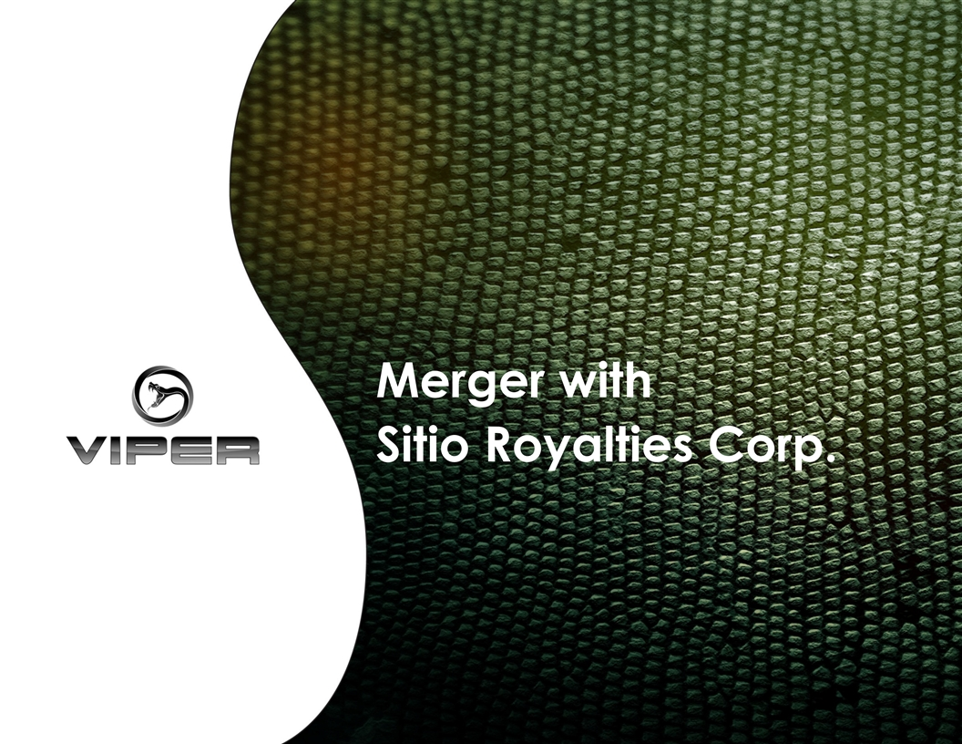
Merger with Sitio Royalties Corp.

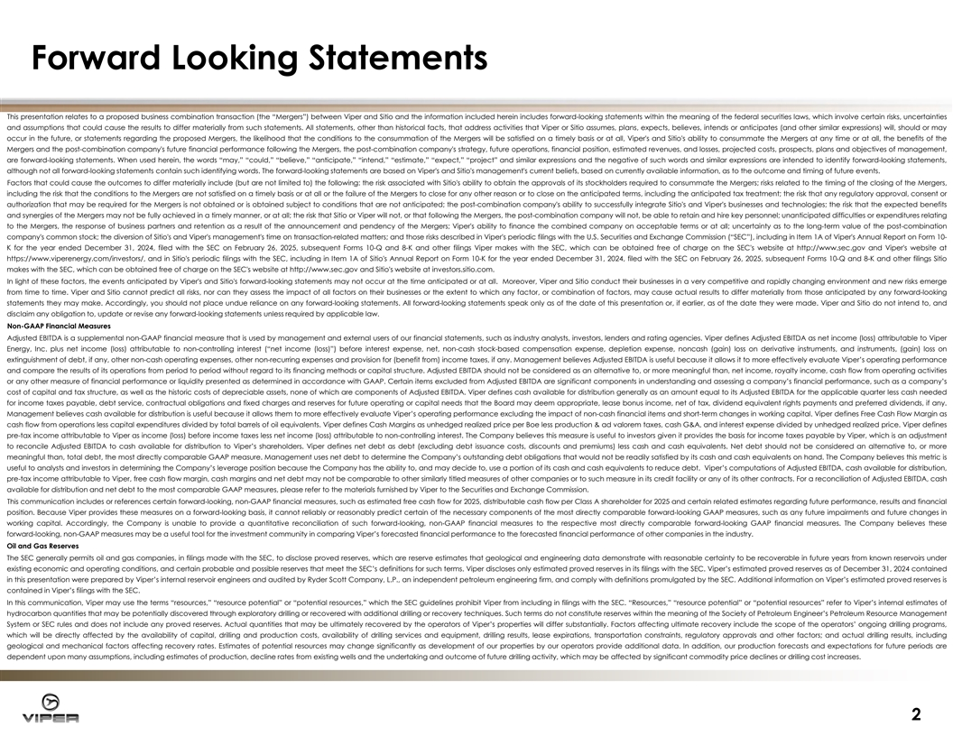
Forward Looking Statements This presentation relates to a proposed business combination transaction (the “Mergers”) between Viper and Sitio and the information included herein includes forward-looking statements within the meaning of the federal securities laws, which involve certain risks, uncertainties and assumptions that could cause the results to differ materially from such statements. All statements, other than historical facts, that address activities that Viper or Sitio assumes, plans, expects, believes, intends or anticipates (and other similar expressions) will, should or may occur in the future, or statements regarding the proposed Mergers, the likelihood that the conditions to the consummation of the Mergers will be satisfied on a timely basis or at all, Viper's and Sitio's ability to consummate the Mergers at any time or at all, the benefits of the Mergers and the post-combination company's future financial performance following the Mergers, the post-combination company's strategy, future operations, financial position, estimated revenues, and losses, projected costs, prospects, plans and objectives of management, are forward-looking statements. When used herein, the words “may,” “could,” “believe,” “anticipate,” “intend,” “estimate,” “expect,” “project” and similar expressions and the negative of such words and similar expressions are intended to identify forward-looking statements, although not all forward-looking statements contain such identifying words. The forward-looking statements are based on Viper's and Sitio's management's current beliefs, based on currently available information, as to the outcome and timing of future events. Factors that could cause the outcomes to differ materially include (but are not limited to) the following: the risk associated with Sitio's ability to obtain the approvals of its stockholders required to consummate the Mergers; risks related to the timing of the closing of the Mergers, including the risk that the conditions to the Mergers are not satisfied on a timely basis or at all or the failure of the Mergers to close for any other reason or to close on the anticipated terms, including the anticipated tax treatment; the risk that any regulatory approval, consent or authorization that may be required for the Mergers is not obtained or is obtained subject to conditions that are not anticipated; the post-combination company's ability to successfully integrate Sitio's and Viper's businesses and technologies; the risk that the expected benefits and synergies of the Mergers may not be fully achieved in a timely manner, or at all; the risk that Sitio or Viper will not, or that following the Mergers, the post-combination company will not, be able to retain and hire key personnel; unanticipated difficulties or expenditures relating to the Mergers, the response of business partners and retention as a result of the announcement and pendency of the Mergers; Viper's ability to finance the combined company on acceptable terms or at all; uncertainty as to the long-term value of the post-combination company's common stock; the diversion of Sitio's and Viper's management's time on transaction-related matters; and those risks described in Viper's periodic filings with the U.S. Securities and Exchange Commission (“SEC”), including in Item 1A of Viper's Annual Report on Form 10- K for the year ended December 31, 2024, filed with the SEC on February 26, 2025, subsequent Forms 10-Q and 8-K and other filings Viper makes with the SEC, which can be obtained free of charge on the SEC's website at http://www.sec.gov and Viper's website at https://www.viperenergy.com/investors/, and in Sitio's periodic filings with the SEC, including in Item 1A of Sitio's Annual Report on Form 10-K for the year ended December 31, 2024, filed with the SEC on February 26, 2025, subsequent Forms 10-Q and 8-K and other filings Sitio makes with the SEC, which can be obtained free of charge on the SEC's website at http://www.sec.gov and Sitio's website at investors.sitio.com. In light of these factors, the events anticipated by Viper's and Sitio's forward-looking statements may not occur at the time anticipated or at all. Moreover, Viper and Sitio conduct their businesses in a very competitive and rapidly changing environment and new risks emerge from time to time. Viper and Sitio cannot predict all risks, nor can they assess the impact of all factors on their businesses or the extent to which any factor, or combination of factors, may cause actual results to differ materially from those anticipated by any forward-looking statements they may make. Accordingly, you should not place undue reliance on any forward-looking statements. All forward-looking statements speak only as of the date of this presentation or, if earlier, as of the date they were made. Viper and Sitio do not intend to, and disclaim any obligation to, update or revise any forward-looking statements unless required by applicable law. Non-GAAP Financial Measures Adjusted EBITDA is a supplemental non-GAAP financial measure that is used by management and external users of our financial statements, such as industry analysts, investors, lenders and rating agencies. Viper defines Adjusted EBITDA as net income (loss) attributable to Viper Energy, Inc. plus net income (loss) attributable to non-controlling interest (“net income (loss)”) before interest expense, net, non-cash stock-based compensation expense, depletion expense, noncash (gain) loss on derivative instruments, and instruments, (gain) loss on extinguishment of debt, if any, other non-cash operating expenses, other non-recurring expenses and provision for (benefit from) income taxes, if any. Management believes Adjusted EBITDA is useful because it allows it to more effectively evaluate Viper’s operating performance and compare the results of its operations from period to period without regard to its financing methods or capital structure. Adjusted EBITDA should not be considered as an alternative to, or more meaningful than, net income, royalty income, cash flow from operating activities or any other measure of financial performance or liquidity presented as determined in accordance with GAAP. Certain items excluded from Adjusted EBITDA are significant components in understanding and assessing a company’s financial performance, such as a company’s cost of capital and tax structure, as well as the historic costs of depreciable assets, none of which are components of Adjusted EBITDA. Viper defines cash available for distribution generally as an amount equal to its Adjusted EBITDA for the applicable quarter less cash needed for income taxes payable, debt service, contractual obligations and fixed charges and reserves for future operating or capital needs that the Board may deem appropriate, lease bonus income, net of tax, dividend equivalent rights payments and preferred dividends, if any. Management believes cash available for distribution is useful because it allows them to more effectively evaluate Viper’s operating performance excluding the impact of non-cash financial items and short-term changes in working capital. Viper defines Free Cash Flow Margin as cash flow from operations less capital expenditures divided by total barrels of oil equivalents. Viper defines Cash Margins as unhedged realized price per Boe less production & ad valorem taxes, cash G&A, and interest expense divided by unhedged realized price. Viper defines pre-tax income attributable to Viper as income (loss) before income taxes less net income (loss) attributable to non-controlling interest. The Company believes this measure is useful to investors given it provides the basis for income taxes payable by Viper, which is an adjustment to reconcile Adjusted EBITDA to cash available for distribution to Viper’s shareholders. Viper defines net debt as debt (excluding debt issuance costs, discounts and premiums) less cash and cash equivalents. Net debt should not be considered an alternative to, or more meaningful than, total debt, the most directly comparable GAAP measure. Management uses net debt to determine the Company’s outstanding debt obligations that would not be readily satisfied by its cash and cash equivalents on hand. The Company believes this metric is useful to analysts and investors in determining the Company’s leverage position because the Company has the ability to, and may decide to, use a portion of its cash and cash equivalents to reduce debt. Viper’s computations of Adjusted EBITDA, cash available for distribution, pre-tax income attributable to Viper, free cash flow margin, cash margins and net debt may not be comparable to other similarly titled measures of other companies or to such measure in its credit facility or any of its other contracts. For a reconciliation of Adjusted EBITDA, cash available for distribution and net debt to the most comparable GAAP measures, please refer to the materials furnished by Viper to the Securities and Exchange Commission. This communication includes or references certain forward-looking, non-GAAP financial measures, such as estimated free cash flow for 2025, distributable cash flow per Class A shareholder for 2025 and certain related estimates regarding future performance, results and financial position. Because Viper provides these measures on a forward-looking basis, it cannot reliably or reasonably predict certain of the necessary components of the most directly comparable forward-looking GAAP measures, such as any future impairments and future changes in working capital. Accordingly, the Company is unable to provide a quantitative reconciliation of such forward-looking, non-GAAP financial measures to the respective most directly comparable forward-looking GAAP financial measures. The Company believes these forward-looking, non-GAAP measures may be a useful tool for the investment community in comparing Viper’s forecasted financial performance to the forecasted financial performance of other companies in the industry. Oil and Gas Reserves The SEC generally permits oil and gas companies, in filings made with the SEC, to disclose proved reserves, which are reserve estimates that geological and engineering data demonstrate with reasonable certainty to be recoverable in future years from known reservoirs under existing economic and operating conditions, and certain probable and possible reserves that meet the SEC’s definitions for such terms. Viper discloses only estimated proved reserves in its filings with the SEC. Viper’s estimated proved reserves as of December 31, 2024 contained in this presentation were prepared by Viper’s internal reservoir engineers and audited by Ryder Scott Company, L.P., an independent petroleum engineering firm, and comply with definitions promulgated by the SEC. Additional information on Viper’s estimated proved reserves is contained in Viper’s filings with the SEC. In this communication, Viper may use the terms “resources,” “resource potential” or “potential resources,” which the SEC guidelines prohibit Viper from including in filings with the SEC. “Resources,” “resource potential” or “potential resources” refer to Viper’s internal estimates of hydrocarbon quantities that may be potentially discovered through exploratory drilling or recovered with additional drilling or recovery techniques. Such terms do not constitute reserves within the meaning of the Society of Petroleum Engineer’s Petroleum Resource Management System or SEC rules and does not include any proved reserves. Actual quantities that may be ultimately recovered by the operators of Viper’s properties will differ substantially. Factors affecting ultimate recovery include the scope of the operators’ ongoing drilling programs, which will be directly affected by the availability of capital, drilling and production costs, availability of drilling services and equipment, drilling results, lease expirations, transportation constraints, regulatory approvals and other factors; and actual drilling results, including geological and mechanical factors affecting recovery rates. Estimates of potential resources may change significantly as development of our properties by our operators provide additional data. In addition, our production forecasts and expectations for future periods are dependent upon many assumptions, including estimates of production, decline rates from existing wells and the undertaking and outcome of future drilling activity, which may be affected by significant commodity price declines or drilling cost increases. 2

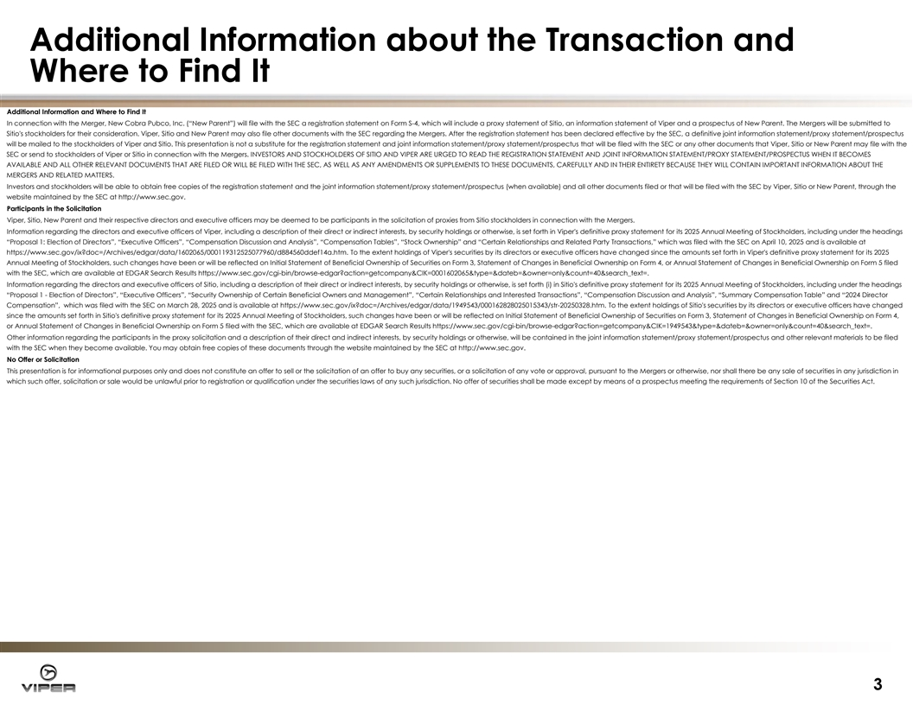
Additional Information about the Transaction and Where to Find It Additional Information and Where to Find It In connection with the Merger, New Cobra Pubco, Inc. (“New Parent”) will file with the SEC a registration statement on Form S-4, which will include a proxy statement of Sitio, an information statement of Viper and a prospectus of New Parent. The Mergers will be submitted to Sitio's stockholders for their consideration. Viper, Sitio and New Parent may also file other documents with the SEC regarding the Mergers. After the registration statement has been declared effective by the SEC, a definitive joint information statement/proxy statement/prospectus will be mailed to the stockholders of Viper and Sitio. This presentation is not a substitute for the registration statement and joint information statement/proxy statement/prospectus that will be filed with the SEC or any other documents that Viper, Sitio or New Parent may file with the SEC or send to stockholders of Viper or Sitio in connection with the Mergers. INVESTORS AND STOCKHOLDERS OF SITIO AND VIPER ARE URGED TO READ THE REGISTRATION STATEMENT AND JOINT INFORMATION STATEMENT/PROXY STATEMENT/PROSPECTUS WHEN IT BECOMES AVAILABLE AND ALL OTHER RELEVANT DOCUMENTS THAT ARE FILED OR WILL BE FILED WITH THE SEC, AS WELL AS ANY AMENDMENTS OR SUPPLEMENTS TO THESE DOCUMENTS, CAREFULLY AND IN THEIR ENTIRETY BECAUSE THEY WILL CONTAIN IMPORTANT INFORMATION ABOUT THE MERGERS AND RELATED MATTERS. Investors and stockholders will be able to obtain free copies of the registration statement and the joint information statement/proxy statement/prospectus (when available) and all other documents filed or that will be filed with the SEC by Viper, Sitio or New Parent, through the website maintained by the SEC at http://www.sec.gov. Participants in the Solicitation Viper, Sitio, New Parent and their respective directors and executive officers may be deemed to be participants in the solicitation of proxies from Sitio stockholders in connection with the Mergers. Information regarding the directors and executive officers of Viper, including a description of their direct or indirect interests, by security holdings or otherwise, is set forth in Viper's definitive proxy statement for its 2025 Annual Meeting of Stockholders, including under the headings “Proposal 1: Election of Directors”, “Executive Officers”, “Compensation Discussion and Analysis”, “Compensation Tables”, “Stock Ownership” and “Certain Relationships and Related Party Transactions,” which was filed with the SEC on April 10, 2025 and is available at https://www.sec.gov/ix?doc=/Archives/edgar/data/1602065/000119312525077960/d884560ddef14a.htm. To the extent holdings of Viper's securities by its directors or executive officers have changed since the amounts set forth in Viper's definitive proxy statement for its 2025 Annual Meeting of Stockholders, such changes have been or will be reflected on Initial Statement of Beneficial Ownership of Securities on Form 3, Statement of Changes in Beneficial Ownership on Form 4, or Annual Statement of Changes in Beneficial Ownership on Form 5 filed with the SEC, which are available at EDGAR Search Results https://www.sec.gov/cgi-bin/browse-edgar?action=getcompany&CIK=0001602065&type=&dateb=&owner=only&count=40&search_text=. Information regarding the directors and executive officers of Sitio, including a description of their direct or indirect interests, by security holdings or otherwise, is set forth (i) in Sitio's definitive proxy statement for its 2025 Annual Meeting of Stockholders, including under the headings “Proposal 1 - Election of Directors”, “Executive Officers”, “Security Ownership of Certain Beneficial Owners and Management”, “Certain Relationships and Interested Transactions”, “Compensation Discussion and Analysis”, “Summary Compensation Table” and “2024 Director Compensation”, which was filed with the SEC on March 28, 2025 and is available at https://www.sec.gov/ix?doc=/Archives/edgar/data/1949543/000162828025015343/str-20250328.htm. To the extent holdings of Sitio's securities by its directors or executive officers have changed since the amounts set forth in Sitio's definitive proxy statement for its 2025 Annual Meeting of Stockholders, such changes have been or will be reflected on Initial Statement of Beneficial Ownership of Securities on Form 3, Statement of Changes in Beneficial Ownership on Form 4, or Annual Statement of Changes in Beneficial Ownership on Form 5 filed with the SEC, which are available at EDGAR Search Results https://www.sec.gov/cgi-bin/browse-edgar?action=getcompany&CIK=1949543&type=&dateb=&owner=only&count=40&search_text=. Other information regarding the participants in the proxy solicitation and a description of their direct and indirect interests, by security holdings or otherwise, will be contained in the joint information statement/proxy statement/prospectus and other relevant materials to be filed with the SEC when they become available. You may obtain free copies of these documents through the website maintained by the SEC at http://www.sec.gov. No Offer or Solicitation This presentation is for informational purposes only and does not constitute an offer to sell or the solicitation of an offer to buy any securities, or a solicitation of any vote or approval, pursuant to the Mergers or otherwise, nor shall there be any sale of securities in any jurisdiction in which such offer, solicitation or sale would be unlawful prior to registration or qualification under the securities laws of any such jurisdiction. No offer of securities shall be made except by means of a prospectus meeting the requirements of Section 10 of the Securities Act. 3

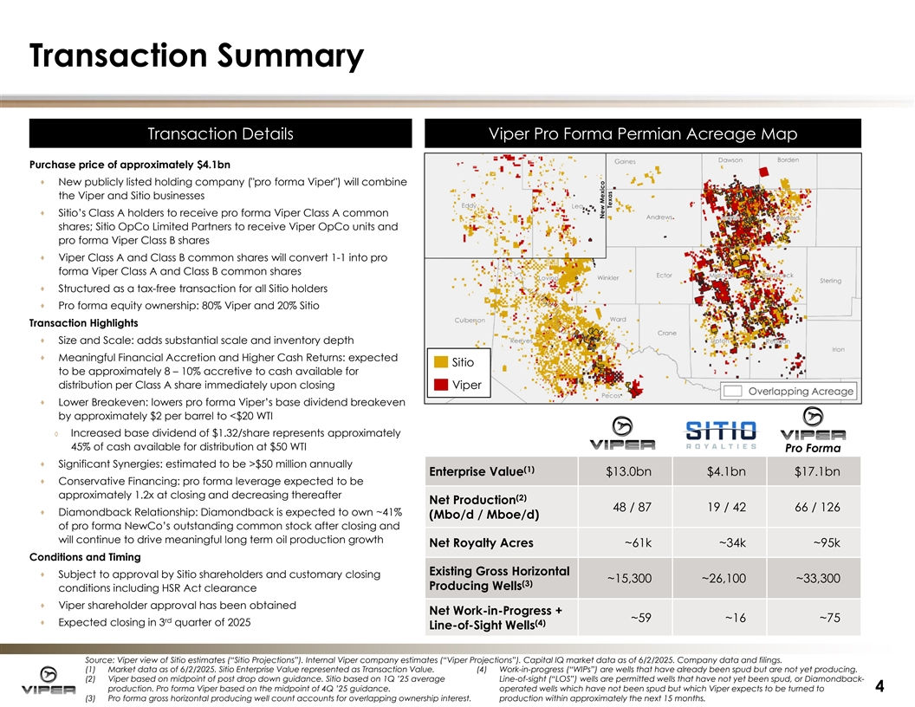
Transaction Summary T Tr ra an ns sa act ction ion D De et ta ails ils Vi Viper Pro Forma Permi per Pro Forma Permia an Acreage n Acreage Map Map Purchase price of approximately $4.1bn · New publicly listed holding company ( pro forma Viper ) will combine the Viper and Sitio businesses · Sitio’s Class A holders to receive pro forma Viper Class A common shares; Sitio OpCo Limited Partners to receive Viper OpCo units and pro forma Viper Class B shares · Viper Class A and Class B common shares will convert 1-1 into pro forma Viper Class A and Class B common shares · Structured as a tax-free transaction for all Sitio holders · Pro forma equity ownership: 80% Viper and 20% Sitio Transaction Highlights · Size and Scale: adds substantial scale and inventory depth · Meaningful Financial Accretion and Higher Cash Returns: expected Sitio to be approximately 8 – 10% accretive to cash available for distribution per Class A share immediately upon closing Viper · Lower Breakeven: lowers pro forma Viper’s base dividend breakeven by approximately $2 per barrel to <$20 WTI ◊ Increased base dividend of $1.32/share represents approximately 45% of cash available for distribution at $50 WTI Pro Forma · Significant Synergies: estimated to be >$50 million annually (1) Enterprise Value $13.0bn $4.1bn $17.1bn · Conservative Financing: pro forma leverage expected to be approximately 1.2x at closing and decreasing thereafter (2) Net Production 48 / 87 19 / 42 66 / 126 · Diamondback Relationship: Diamondback is expected to own ~41% (Mbo/d / Mboe/d) of pro forma NewCo’s outstanding common stock after closing and will continue to drive meaningful long term oil production growth Net Royalty Acres ~61k ~34k ~95k Conditions and Timing Existing Gross Horizontal · Subject to approval by Sitio shareholders and customary closing ~15,300 ~26,100 ~33,300 (3) Producing Wells conditions including HSR Act clearance · Viper shareholder approval has been obtained Net Work-in-Progress + rd ~59 ~16 ~75 · Expected closing in 3 quarter of 2025 (4) Line-of-Sight Wells Source: Viper view of Sitio estimates (“Sitio Projections”). Internal Viper company estimates (“Viper Projections”). Capital IQ market data as of 6/2/2025. Company data and filings. (1) Market data as of 6/2/2025. Sitio Enterprise Value represented as Transaction Value. (4) Work-in-progress (“WIPs”) are wells that have already been spud but are not yet producing. (2) Viper based on midpoint of post drop down guidance. Sitio based on 1Q ’25 average Line-of-sight (“LOS”) wells are permitted wells that have not yet been spud, or Diamondback- production. Pro forma Viper based on the midpoint of 4Q ’25 guidance. operated wells which have not been spud but which Viper expects to be turned to 4 (3) Pro forma gross horizontal producing well count accounts for overlapping ownership interest. production within approximately the next 15 months.

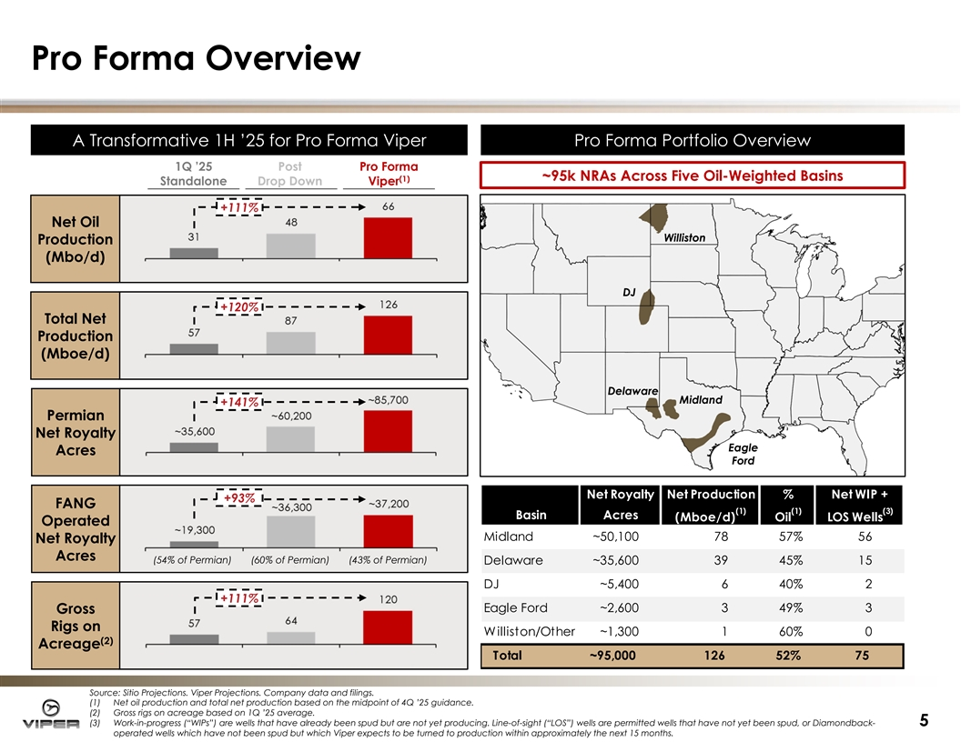
Pro Forma Overview A Transformati A Transformative 1H ’25 ve 1H ’25 for Pro for Pro Forma Vi Forma Viper per Pro Forma Portfolio Pro Forma Portfolio Overvi Overview ew 1Q ’25 Post Pro Forma ~95k NRAs Across Five Oil-Weighted Basins (1) Standalone Drop Down Viper +111% Net Oil Williston Production (Mbo/d) DJ +120% Total Net Production (Mboe/d) Delaware Midland +141% Permian Net Royalty Eagle Acres Ford Net Royalty Net Production % Net WIP + +93% FANG (1) (1) (3) Basin Acres (Mboe/d) Oil LOS Wells Operated Midland ~50,100 78 57% 56 Net Royalty Acres (54% of Permian) (60% of Permian) (43% of Permian) Delaware ~35,600 39 45% 15 DJ ~5,400 6 40% 2 +111% Eagle Ford ~2,600 3 49% 3 Gross Rigs on Williston/Other ~1,300 1 60% 0 (2) Acreage Total ~95,000 126 52% 75 Source: Sitio Projections. Viper Projections. Company data and filings. (1) Net oil production and total net production based on the midpoint of 4Q ’25 guidance. (2) Gross rigs on acreage based on 1Q ’25 average. (3) Work-in-progress (“WIPs”) are wells that have already been spud but are not yet producing. Line-of-sight (“LOS”) wells are permitted wells that have not yet been spud, or Diamondback- 5 operated wells which have not been spud but which Viper expects to be turned to production within approximately the next 15 months.

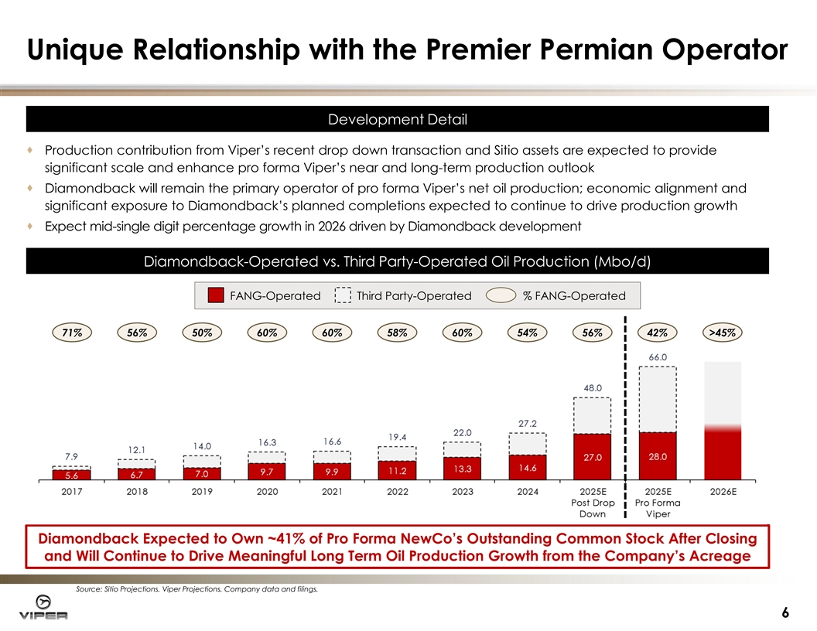
Unique Relationship with the Premier Permian Operator Development Development D De et ta aiill · Production contribution from Viper’s recent drop down transaction and Sitio assets are expected to provide significant scale and enhance pro forma Viper’s near and long-term production outlook · Diamondback will remain the primary operator of pro forma Viper’s net oil production; economic alignment and significant exposure to Diamondback’s planned completions expected to continue to drive production growth · Expect mid-single digit percentage growth in 2026 driven by Diamondback development Diamondback-O Diamondback-Op pe er ra at te ed d vs. vs. Third Third Party-Operated O Party-Operated Oiill P Pr ro od du uc ct tiio on n ( (Mbo/d) Mbo/d) FANG-Operated Third Party-Operated % FANG-Operated 71% 56% 50% 60% 60% 58% 60% 54% 56% 42% >45% Diamondback Expected to Own ~41% of Pro Forma NewCo’s Outstanding Common Stock After Closing and Will Continue to Drive Meaningful Long Term Oil Production Growth from the Company’s Acreage Source: Sitio Projections. Viper Projections. Company data and filings. 6

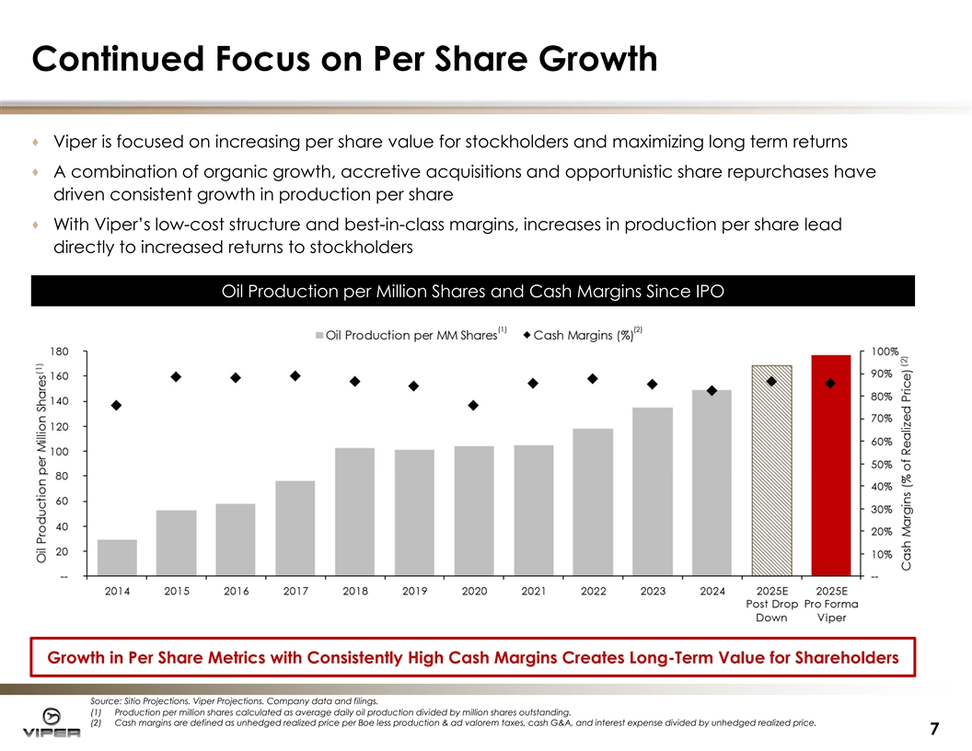
Continued Focus on Per Share Growth · Viper is focused on increasing per share value for stockholders and maximizing long term returns · A combination of organic growth, accretive acquisitions and opportunistic share repurchases have driven consistent growth in production per share · With Viper’s low-cost structure and best-in-class margins, increases in production per share lead directly to increased returns to stockholders Oi Oil Producti l Production per on per Mi Million Shares llion Shares and and Cash Cash Margi Margin ns s Si Since nce IPO IPO (1) (2) Growth in Per Share Metrics with Consistently High Cash Margins Creates Long-Term Value for Shareholders Source: Sitio Projections. Viper Projections. Company data and filings. (1) Production per million shares calculated as average daily oil production divided by million shares outstanding. (2) Cash margins are defined as unhedged realized price per Boe less production & ad valorem taxes, cash G&A, and interest expense divided by unhedged realized price. 7

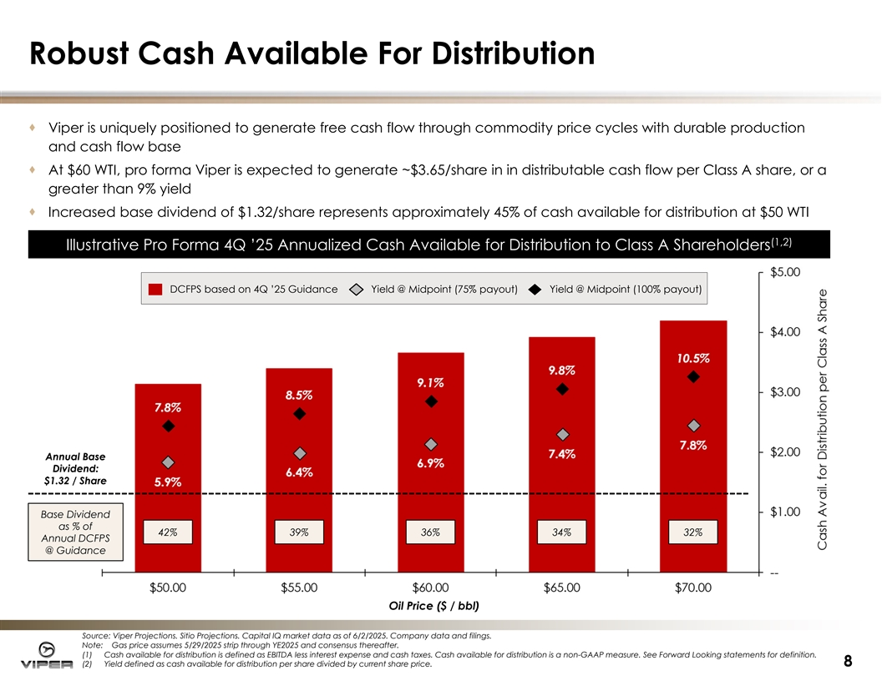
Robust Cash Available For Distribution · Viper is uniquely positioned to generate free cash flow through commodity price cycles with durable production and cash flow base · At $60 WTI, pro forma Viper is expected to generate ~$3.65/share in in distributable cash flow per Class A share, or a greater than 9% yield · Increased base dividend of $1.32/share represents approximately 45% of cash available for distribution at $50 WTI (1 (1, ,2 2) ) Illustrati Illustrative ve Pro Forma 4Q ’25 Annuali Pro Forma 4Q ’25 Annualiz zed Cash Av ed Cash Avai ailable for Di lable for Distribution stribution to Class A to Class A Shareholders Shareholders DCFPS based on 4Q ’25 Guidance Yield @ Midpoint (75% payout) Yield @ Midpoint (100% payout) Annual Base Dividend: $1.32 / Share Base Dividend as % of 42% 39% 36% 34% 32% Annual DCFPS @ Guidance Oil Price ($ / bbl) Source: Viper Projections. Sitio Projections. Capital IQ market data as of 6/2/2025. Company data and filings. Note: Gas price assumes 5/29/2025 strip through YE2025 and consensus thereafter. (1) Cash available for distribution is defined as EBITDA less interest expense and cash taxes. Cash available for distribution is a non-GAAP measure. See Forward Looking statements for definition. (2) Yield defined as cash available for distribution per share divided by current share price. 8

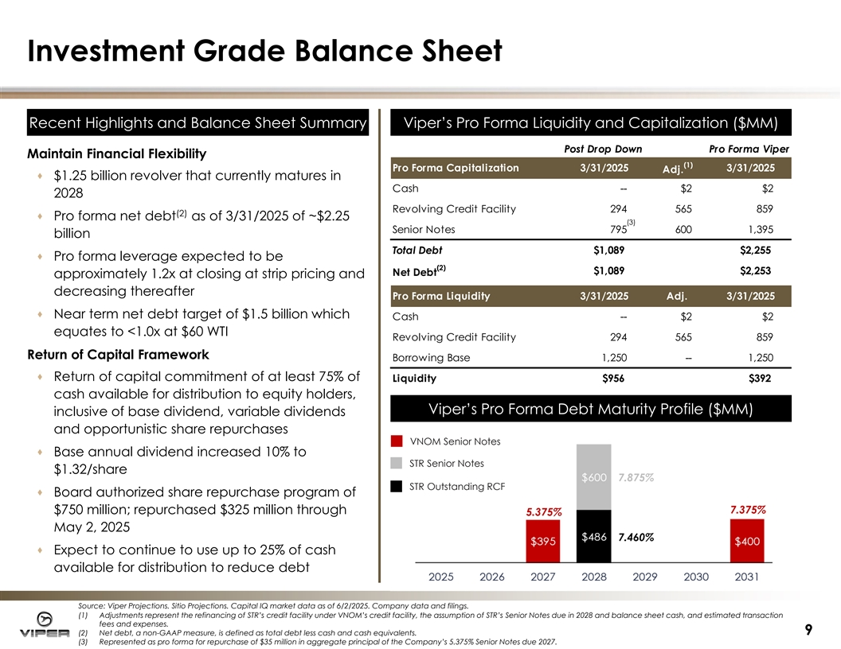
Investment Grade Balance Sheet Recent Hi Recent Highlights ghlights and Balance Sheet Summary and Balance Sheet Summary Vi Viper’s Pro Forma per’s Pro Forma Li Liquidity quidity and and Capi Capitali talizati zation ($MM) on ($MM) Post Drop Down Pro Forma Viper Maintain Financial Flexibility (1) Pro Forma Capitalization 3/31/2025 3/31/2025 Adj. · $1.25 billion revolver that currently matures in Cash -- $2 $2 2028 Revolving Credit Facility 294 565 859 (2) · Pro forma net debt as of 3/31/2025 of ~$2.25 (3) Senior Notes 795 600 1,395 billion $1,089 $2,255 Total Debt · Pro forma leverage expected to be (2) $1,089 $2,253 Net Debt approximately 1.2x at closing at strip pricing and decreasing thereafter Pro Forma Liquidity 3/31/2025 Adj. 3/31/2025 · Near term net debt target of $1.5 billion which Cash -- $2 $2 equates to <1.0x at $60 WTI Revolving Credit Facility 294 565 859 Return of Capital Framework Borrowing Base 1,250 -- 1,250 · Return of capital commitment of at least 75% of Liquidity $956 $392 cash available for distribution to equity holders, Vi Viper’s per’s Pro Forma Debt Maturi Pro Forma Debt Maturity Profi ty Profille e ($MM) ($MM) inclusive of base dividend, variable dividends and opportunistic share repurchases VNOM Senior Notes · Base annual dividend increased 10% to STR Senior Notes $1.32/share 7.875% STR Outstanding RCF · Board authorized share repurchase program of 7.375% $750 million; repurchased $325 million through 5.375% May 2, 2025 7.460% · Expect to continue to use up to 25% of cash available for distribution to reduce debt Source: Viper Projections. Sitio Projections. Capital IQ market data as of 6/2/2025. Company data and filings. (1) Adjustments represent the refinancing of STR’s credit facility under VNOM’s credit facility, the assumption of STR’s Senior Notes due in 2028 and balance sheet cash, and estimated transaction fees and expenses. 9 (2) Net debt, a non-GAAP measure, is defined as total debt less cash and cash equivalents. (3) Represented as pro forma for repurchase of $35 million in aggregate principal of the Company’s 5.375% Senior Notes due 2027.

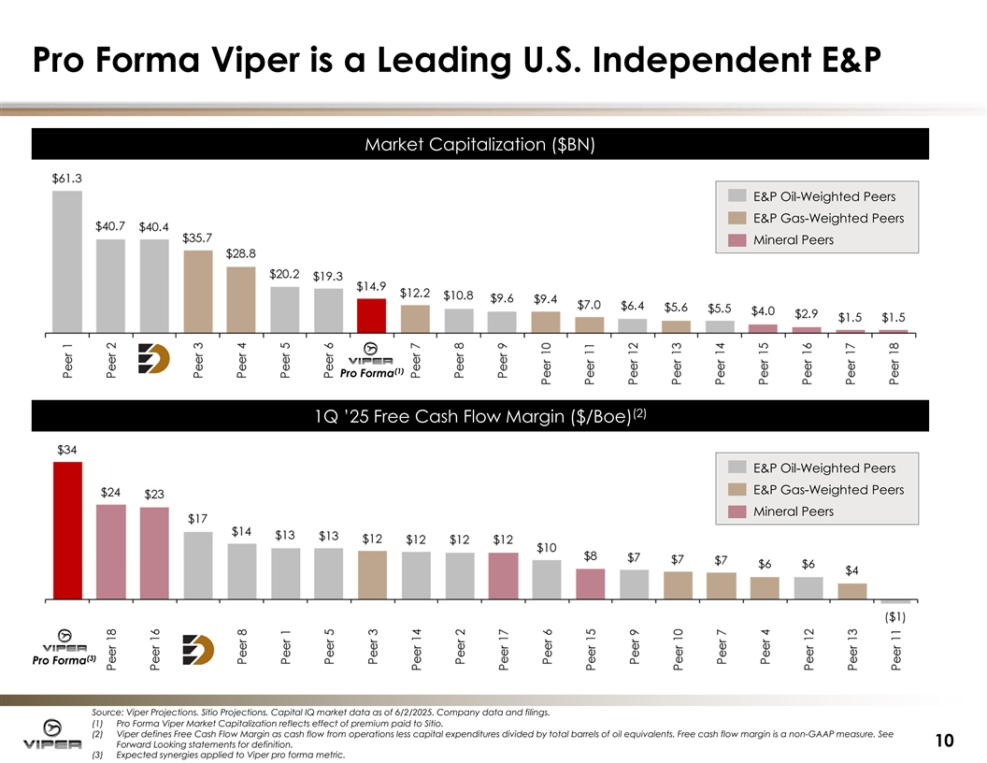
Pro Forma Viper is a Leading U.S. Independent E&P Market Capi Market Capitali talizati zation on ( ($ $BN) BN) E&P Oil-Weighted Peers E&P Gas-Weighted Peers Mineral Peers (1) Pro Forma (2 (2) ) 1Q ’25 1Q ’25 Free Cash Flow Free Cash Flow Margi Margin n ( ($ $/Boe) /Boe) E&P Oil-Weighted Peers E&P Gas-Weighted Peers Mineral Peers (3) Pro Forma Source: Viper Projections. Sitio Projections. Capital IQ market data as of 6/2/2025. Company data and filings. (1) Pro Forma Viper Market Capitalization reflects effect of premium paid to Sitio. (2) Viper defines Free Cash Flow Margin as cash flow from operations less capital expenditures divided by total barrels of oil equivalents. Free cash flow margin is a non-GAAP measure. See 10 Forward Looking statements for definition. (3) Expected synergies applied to Viper pro forma metric.

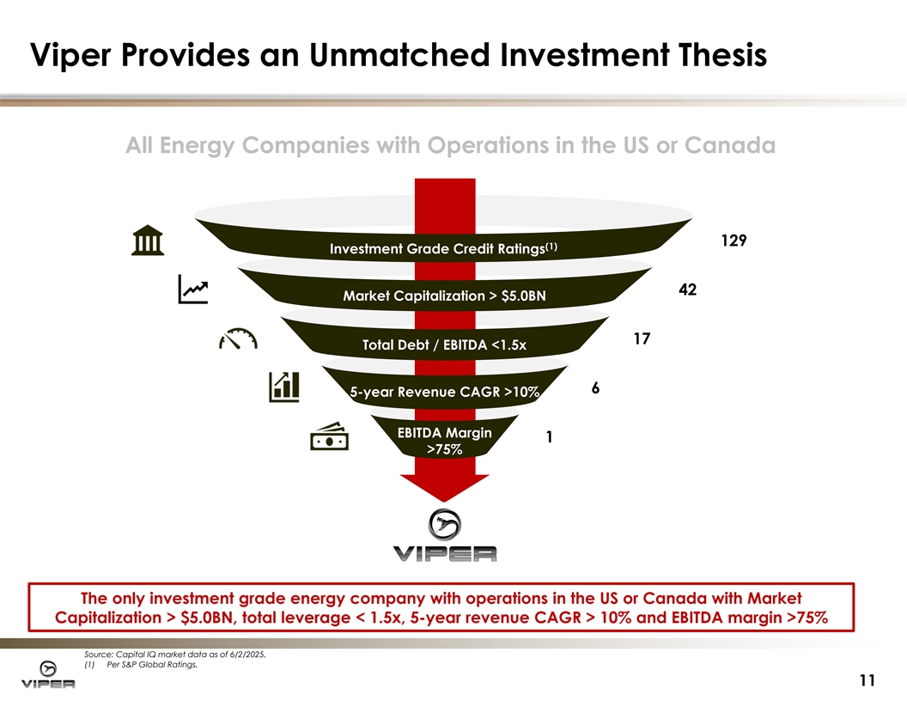
Viper Provides an Unmatched Investment Thesis All Energy Companies with Operations in the US or Canada 129 (1) Investment Grade Credit Ratings 42 Market Capitalization > $5.0BN 17 Total Debt / EBITDA <1.5x 6 5-year Revenue CAGR >10% EBITDA Margin 1 >75% The only investment grade energy company with operations in the US or Canada with Market Capitalization > $5.0BN, total leverage < 1.5x, 5-year revenue CAGR > 10% and EBITDA margin >75% Source: Capital IQ market data as of 6/2/2025. (1) Per S&P Global Ratings. 11

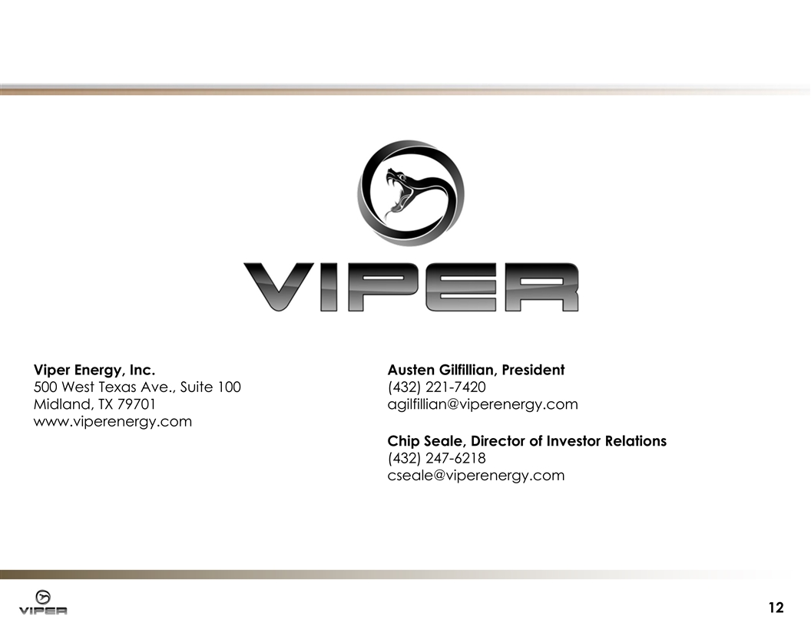
Viper Energy, Inc. Austen Gilfillian, President 500 West Texas Ave., Suite 100 (432) 221-7420 Midland, TX 79701 agilfillian@viperenergy.com www.viperenergy.com Chip Seale, Director of Investor Relations (432) 247-6218 cseale@viperenergy.com 12

